Supplementary to:

*A surface faulting database of the Idaho Lost River Fault from a systematic-high-quality topographic analysis*

Simone Bello1-2, Chelsea P. Scott3, Federica Ferrarini1-2, Francesco Brozzetti1-2, Tyler Scott3, Daniele Cirillo1-2, Rita De Nardis1-2, J Ramòn Arrowsmith3, Giusy Lavecchia1-2

1DiSPUTer- Department of Psychological, Humanistic and Territorial Sciences, University G. d’Annunzio Chieti-Pescara, Italy.

2CRUST- InterUniversity Center for 3D Seismotectonics with territorial applications, Italy

3School of Earth and Space Exploration – Arizona State University

GUIDE TO USING THE COMPUTATIONAL TOOLS

|  |  |
| --- | --- |
| Table of Contents | |
|  |  |
| **1)** **Introduction and functioning of the code**……………..................................................... | 2 |
| **2)** **Data acquisition**………………………………………..…………………………………. | 2 |
| **3)** **Data preparation**…………………………………………………………………………. | 2 |
| 3.1) Digital Elevation Model……………………………………………………………….. | 2 |
| 3.1.1) ArcMap (ESRI ArcGIS®) “Split Raster” tool.….…………........................ | 2 |
| 3.2) Fault traces…………………………………………………………………………….. | 4 |
| 3.2.1) ArcMap (ESRI ArcGIS®) “Densify” tool….……………………………... | 4 |
| **4)** **The .m file “Calculate_scarp_height**”…………………………………………………… | 6 |
| 4.1) Input data…………………...……..…………………………………………………… | 6 |
| 4.2) Topographic profiles traces generation……………………………………................... | 7 |
| 4.3) Along-profile vertical separation measurements ………………………………………. | 10 |
| 4.3.1) Function “scarp_height_offset.m”…………………………………..… | 10 |
| 4.3.2) Function “line_fitting.m”……………………………………………..…. | 12 |
| 4.3.3Function“scarp_height_save.m”…………………………….…………… | 12 |

1. **INTRODUCTION AND FUNCTIONING OF THE CODE**

We have studied in detail the topography along the Lost River Fault in Idaho (USA) and in particular the rupture zone generated by the strong 1983 Borah Peak earthquake (MW 6.9) almost 40 years after its occurrence.

By using an Unmanned Aerial Vehicle (UAV), we acquired imagery along key areas. Then we processed them generating point clouds, digital surface models (DSMs), and orthomosaics.

Our first reason for acquiring these data was to systematically measure vertical separation along the fault, providing then a database useful for subsequent interpretations.

To do this we have developed and implemented a scarp analysis algorithm in MATLAB (www.mathworks.com) which enables users to measure the vertical separation from a topographic profile. The code constructs a topographic profile along the preferred trend (generally perpendicular to the fault trace) and projects the best-fit lines to each of the hanging wall and footwall flat to the fault location. The vector difference between the intersection of these lines with a vertical plane at the fault location is the vertical separation.

The data input includes Digital Elevation Models (DEM; in UTM projection) surrounding the fault zone and manually-mapped faults saved in shapefiles (SHP). The algorithm shows the topographic profile and the manually mapped faults. The user indicates the hanging wall, the footwall, and the fault location. The algorithm then calculated the vertical separation.

This guide was born from the intention of wanting to make public and replicable the methodology that we have developed for this study, which follows a precise workflow, illustrated here in its individual steps. It is deposited in the GitHub repository (<https://github.com/cpscottasu/FaultVerticalSeparation>) together with the original code and an example dataset. A second copy with this guide and the example dataset has been uploaded to figshare.

1. **DATA ACQUISITION**

To use this code, it is preferable that the faults have had an appreciable vertical separation given the resolution of the DEM. For example, the code is not ideal for measuring a displacement of a few centimetres with a 30m/px DEM resolution.

1. **DATA PREPARATION**
   1. **Digital Elevation Model**

The acquired DEMs must be processed correctly and must not contain errors such as holes with missing data that would result in an interrupted topographic profile as error along the trace.

3.1.1) ArcMap (ESRI ArcGIS®) “Split Raster” tool

There may be difficulties in processing DEMs of too large area sizes; in this case, you can use the "Split Raster" tool available with the ArcMap which will divide the DEMs into smaller portions.

The procedure for ArcMap is as follows:

* Load the raster.
* In "Data Management" choose the "Split Raster" tool (Fig. 1).
* In the window that opens, load the DEM to be split in "*Input Raster*" by dragging it from the "*Table of Contents*" or by searching for it in the original folder.
* Indicate in the “*Output Folder*” the destination folder in which to save the split DEMs;
* In "*Output Base Name*" indicate the base name you want to assign to the output DEMs;
* In "*Split Method*" choose the method to split the DEM. If you want to use the entire DEM available, choose "*NUMBER OF TILES*". If you want to use only a portion of the DEM available, choose "*SIZE_OF_TILE*" and specify the width and height of the DEM, or "*POLYGON_FEATURES*" if you want to split the DEM based on an existing polygon.
* If you have chosen "*NUMBER OF TILES*" indicate in “*Number of Output Rasters*”, the number of DEMs that you want to obtain is given by the x direction and the y direction. A number will be appended to each DEM Base Name, starting with 0.
* In "Resampling Technique" indicate "*NEAREST*", the method that minimizes changes to pixel values.
* Click "*OK*"
* Check that the split has been done correctly by uploading the DEMs to ArcMap directly from the Output Folder (example in Fig. 2).

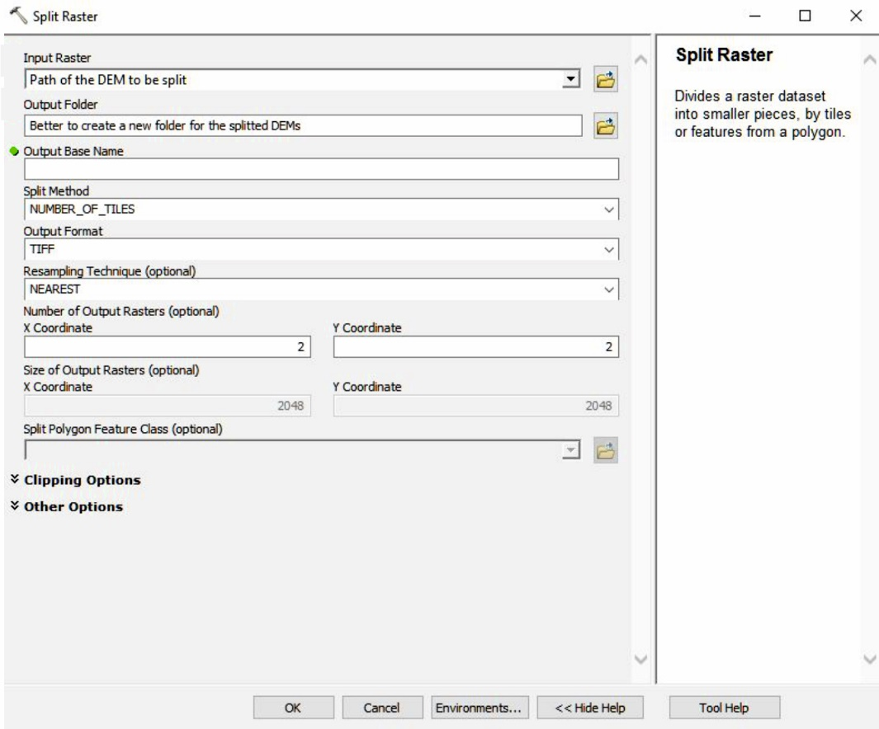

Figure 1 - Screenshot of the "Split raster" tool window

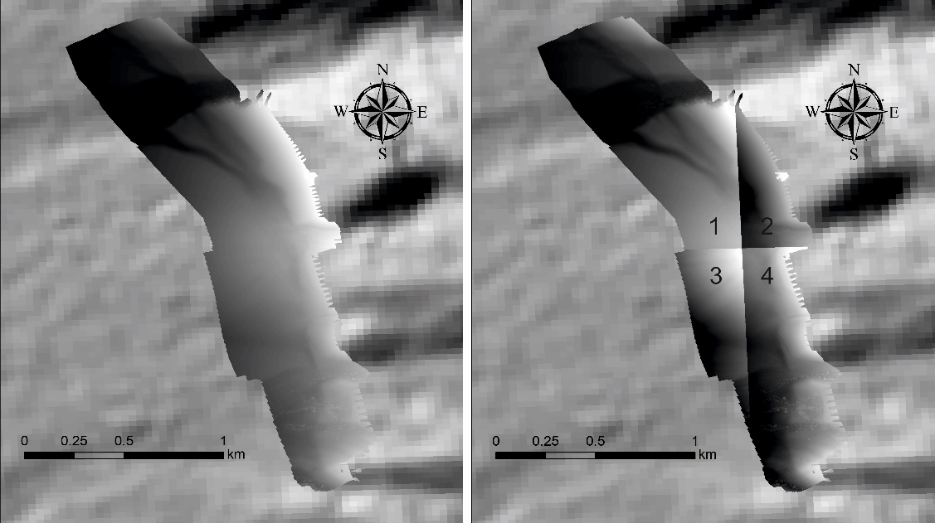

Figure 2 - Example of a DEM before and after the split into four smaller pieces.

* 1. **Fault Traces**

To measure vertical displacement, the users must create a ‘polyline’ feature (ESRI shapefile) with the surface fault traces (example in Fig. 3).

The shapefile should include several attributes that are needed in the MATLAB component, but this is optional and depending on what the user needs to visualize in the MATLAB interface. In the shapefile’s attributes table, we reported fault dip direction, an identification number for each mapped trace and a quality parameter based on the evidence for the mapped fault. In our work we reported as fault dip in the attributes table an “E” for ruptures dipping ~East and a “W” for ruptures dipping ~West because the Lost River Fault strikes N25W.

3.2.1) ArcMap (ESRI ArcGIS®) “Densify” tool

Once all the traces have been mapped, it is necessary that each of the polylines consists of equidistant vertices dense enough to be read by the code. If there is too much spacing between them, the algorithm will miss the mapped faults.

To have the lines of the shapefile with vertices sufficiently close and equidistant you will need to use the ArcMap tool "Densify":

* In "Editing" choose the "Densify" tool (Fig. 4).
* In the window that opens, load the shapefile by dragging it from the "Table of Contents" directly into the "Input Features" field or by searching in the source folder.
* In the "Densification Method" check "DISTANCE".
* In "Distance" indicate the distance between the vertices and choose the unit of measurement. We recommend choosing a distance of a few tens of centimeters (e.g. 50 cm) to make sure there can be a vertex within the distance imposed to the algorithm.
* Click "OK";
* To check that the above was successful, put the shapefile in an edit session and double click from the "edit tool" or "edit vertices" on a trace. Measure the distance between the vertices with the ruler tool.

We suggest using a copy of the original SHP because this procedure modifies the input data.

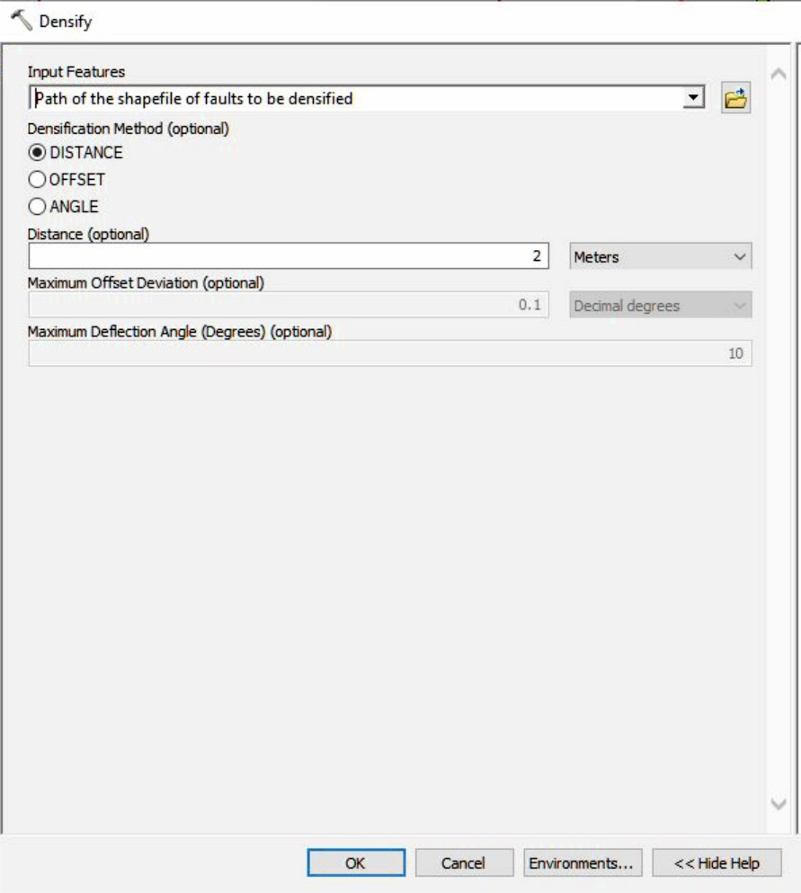

Figure 4 - Screenshot of the "Densify" tool window.

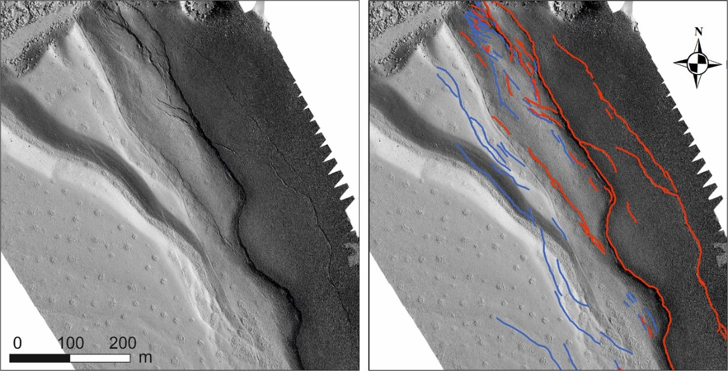

Figure 3 - Example of a DEM before and after the fault trace mapping. Red are WSW-dipping (synthetic), blue are ENE-dipping (antithetic).

1. **The .m file “Calculate_scarp_height”**

The MATLAB code is organized in a series of scripts. The working script from which to define the commands is “Calculate_scarp_height.m” (described below). First, decide the average strike of the fault traces. The algorithm will draw the topographic profiles perpendicular to this strike. Depending on the scale of interest, you can use a single or multiple strikes. The choice of different strikes entails running the code several times in succession. We have annotated important portions of the scripts below.

**4.1) Input data**

Below we describe the fundamental input data to be included in the script.

clear all;close all

dem_folder=' \'; %Enter the path where the clipped DEMs were saved (see paragraph 3.1 of this guide); DEM folder ends with \

base_name= ''; %Indicate the base name (the prefix for each of the raster datasets you have created) without the number that has been appended to each prefix

dem_numbers=[e.g.: 0:3]; %Indicate the numbers that have been appended to each prefix [from:to] (from the splitting process if used)

first_transect_number=1; %Indicate the number of the first topographic profile

faults=shaperead(''); %Indicate the shapefile’s path (see paragraph 3.2 of this guide)

folder_to_save=''; %indicate the path where to save the measurements

strike=350; %assign here the strike of the structure described above. %The topographic profiles will be perpendicular to strike;

swath_spacing=50; %Indicate here (in meters) the topographic profile spacing

swath_width= 5; %indicate (in meters) the width (perpendicular to the transect) of the of the topographic profile. %We recommend ~2/5 m.

strike_window=swath_spacing;

load_DEM % Once the input information has been entered, the DEMs can be loaded

%below, this rotate to be parallel to the major fault system. Translate to have(0m,0m) near DEM.

coordinate_shift=[0 0];

[xt,yt] = coordinate_rotate(x_UTM,y_UTM,strike,coordinate_shift,0);

coordinate_shift=[min(xt) min(yt)];

[x,y] = coordinate_rotate(x_UTM,y_UTM,strike,coordinate_shift,0);

clear xt yt

figure

scatter(x(1:1000:end)/1e3,y(1:1000:end)/1e3,5,z(1:1000:end),'filled')

axis equal

xlabel('rotated x (km)');ylabel('rotated y (km)');title('elevation (m)')

% This generates the rotated DEM figure parallel to the major fault system. Make sure the figure shown well represents the shape and resolution of the input DEM.

**4.2) Topographic profiles traces generation**

“list=[min(y(:))+25:swath_spacing:max(y(:))-25]”

“make_text_file” %This creates and save a text file (.txt) in the output folder. The text file reports the x and y coordinate values of the start-points and end-points of the topographic profiles.

Check the start- and end- points of the topographic profiles generated by the code and saved in the folder "folder_to_save". These points indicate the topographic profiles used to: 1) check the position of the fault intersection along the topographic profiles and 2) adjust geometric and/or geological information on a GIS platform.

To generate the traces starting from the .txt file just created, order the data in columns (a Microsoft Excel spreadsheets (XLS) and use the "*TEXT.TO.COLUMNS*" function with a ‘space’ column separator).

To generate the traces of the topographic profiles, you can use an ArcMap (ESRI ArcGIS®) tool (Fig. 5), called “XY To Line”; the procedure is as follows:

* In *"Data Management*" choose the "*XY To Line*" tool.
* In the window that opens, drag the .txt file to the "*Input Table*" or choose it in the source folder with the appropriate button located to the right of the field;
* In "*Output Feature Class*" indicate the path and name for the saved file.
* In the following four fields, indicate the column position for the latitude and longitude coordinates.
* In "*Line Type*" leave the default.
* In “*ID*” choose the field where the number assigned to the profiles is positioned in the .txt;
* In "*Spatial Reference*" indicate the Coordinate System.
* Click "*OK*".
* Upload the newly created shapefile into ArcMap (ESRI ArcGIS®) (example in Fig. 6).

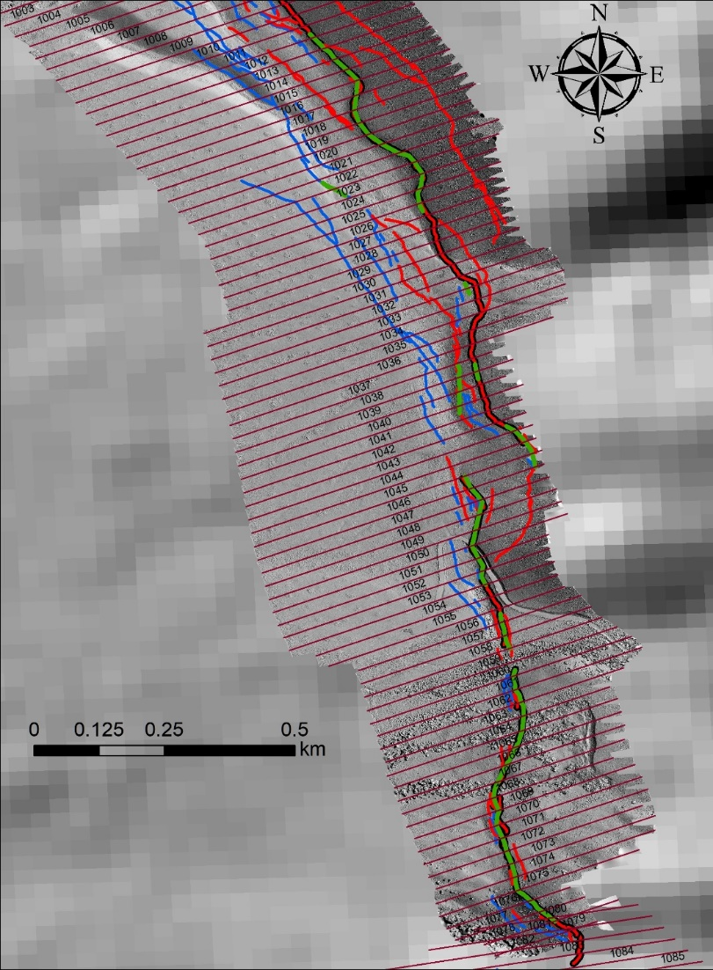

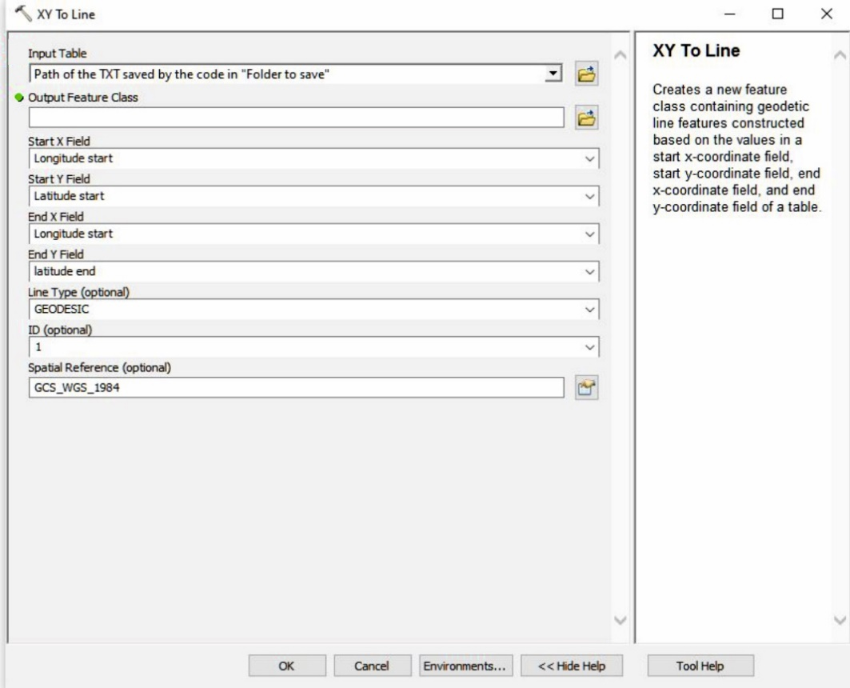

Figure 5 - Screenshot of the "XY To Line" tool window.

Figure 6 - Example of an hillshade in ArcMap with topographic profiles traces obtained using the "XY To Line" tool. Red lines are WSW-dipping (thick if main trace), blue are ENE-dipping, green are Quaternary fault scarps traces. The numbered parallel black lines are the traces of the topographic profiles.

**4.3) Along-profile vertical separation measurements**

After setting the input data and generating the traces of the topographic profiles to be measured, we move on to measuring the vertical separation using the second part of the "calculate_scarp_heigh.m" script here described and the functions belonging to it.

for i=1:1:length(list) %Indicate the number of the topographic profile from which you want to start measuring and the measurement step (all the profiles or 1 every 2 etc.)

close all

disp(['Transect #', num2str(i)])

t=list(i);

xbox1=[min(x) max(x) max(x) min(x)];ybox1=[t t t+swath_width t+swath_width];

c=inpolygon(x,y,xbox1,ybox1);c=find(c==1);

close all

zc=z(c);

xc=x(c);

transect_base_map1 %This show the DEM with created topographic profiles on it

close all

scarp_height_offset %prompt user for input about fault location; calculate the vertical separation. (see paragraph 4.3.1 of this guide)

scarp_height_save %This save the MATLAB structure with the results and save the graphics with output of the mapped faults and vertical separation. (see paragraph 4.3.3 of this guide)

close all

end

**4.3.1) Function “**scarp_height_offset.m**”**

The topographic profiles that were generated in the previous step (see 4.2), are displayed in an interactive window in MATLAB which therefore allows the topographic analysis and the measurement of vertical separations. For each profile, the codes asks “do you want to pick any faults? 1 = yes; 2 = no". A “no” answer will move to the next profile. A ‘Yes’ answer will begin the following:

The graphic interface shows vertical lines indicating the mapped fault position (see paragraph 3.2) along the topographic profile (Fig. 7a);

* Two points to be picked on the hanging wall of the trace. A line is fit to the hanging wall topography (points 1 and 2 in Fig. 7b);
* Two points along the footwall (points 3 and 4 in Fig. 7b);
* A fifth point to the vertical line corresponding to the fault intersection with the profile. This is used to associate the measurement with the fault ID. (point 5 in Fig. 7b);
* A sixth point at the fault position, considering scarp degradation and slope deposit accumulation (point 6 in Fig. 7b);
* The graphical interface closes after the sixth click and reopens showing the footwall and the hangingwall best-fit lines, and the vertical displacement (in centimetres). The vertical displacement is computed from the difference in elevation between the best-fit lines at the fault location.
* The user decides to keep the measurement or delete it and start again.

If the user keeps the measurement, the following parameters are saved.

* Type of object (coseismic displacement (1) or long-term scarp (2));
* Quality ranking (1 to 4);
* The user can make another measurement by answering ‘yes’ to "Do you want to pick another fault?"

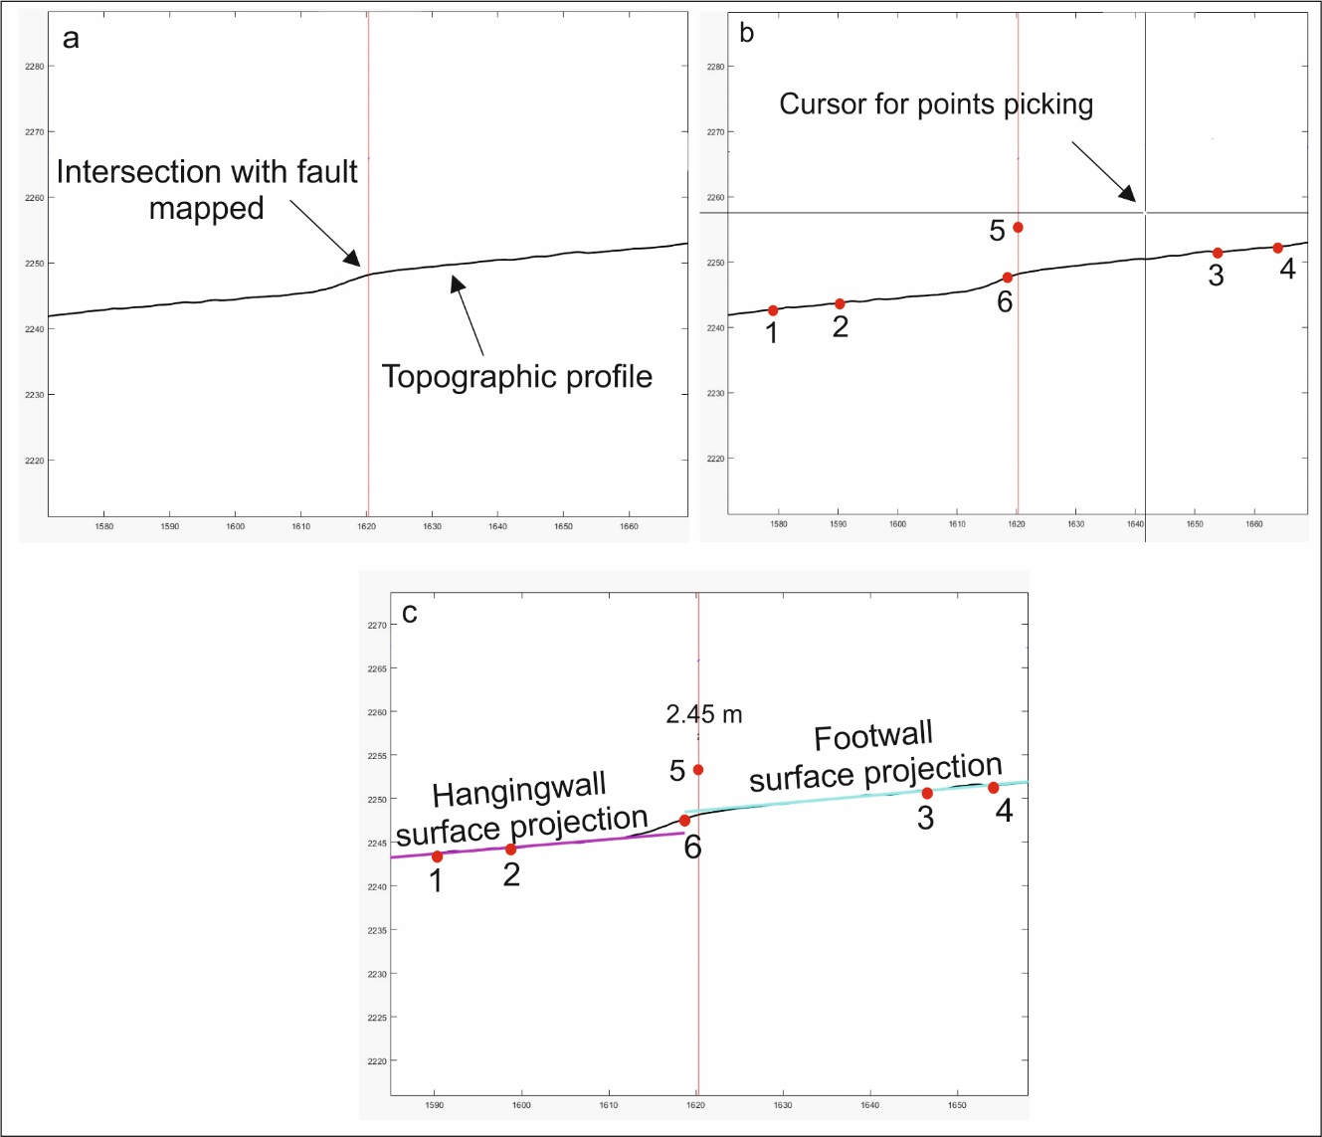

Figure 7 – Example of measuring vertical displacement along a topographic profile on the code graphic interface.

**4.3.2) Function “**line_fitting.m**”**

This code fits lines to the hanging wall and footwall surfaces. The lines are then projected to the fault location.

a=find(average_height(:,1)>fault_points(1)&average_height(:,1)<fault_points(2));

a1=find(average_height(:,1)>fault_points(4)&average_height(:,1)<fault_points(5));

if length(a)<2 |length(a1)<2

disp('Lines not long enough')

return

end

g=[ones(size(a)),average_height(a,1)];

m=inv(g'*g)*g'*average_height(a,2);

g_proj=[1 average_height(a(1),1); 1 fault_points(3)];

pts_proj1=g_proj*m;

plot( [average_height(a(1),1); fault_points(3)],pts_proj1,'-m','LineWidth',3)

g=[ones(size(a1)),average_height(a1,1)];

m=inv(g'*g)*g'*average_height(a1,2);

g_proj=[1 fault_points(3); 1 average_height(a1(end),1)];

pts_proj2=g_proj*m;

plot( [ fault_points(3) average_height(a1(end),1)],pts_proj2,'-c','LineWidth',3)

fault_height=pts_proj2(1)-pts_proj1(2);

text(fault_points(3),pts_proj2(2)+5,num2str(round(fault_height,2)))

**4.3.3) Function “**scarp_height_save.m**”**

Once a profile is complete, the following parameters are saved by MATLAB as a .mat file (MATLAB data file):

* xyz position of each clicked point;
* FW- and HW-linear projections;
* vertical separation;
* measure-quality ranking;
* type of object measured (coseismic displacement or long-term scarp);
* graphical output as PDF files (or any format preferred by the user such as .jpeg, or .eps).